**NEW HEARING AID TECHNOLOGY**

**Bluetooth Devices**:

1. **Phonak Roger Pen:** Transmitter for home use with FM receivers. Can connect to any Bluetooth device - e.g. cell phones, MP3 players, laptops. $725
2. **Phonak ComPilot II:** To wirelessly connect different Bluetooth® devices (cell phones, MP3 players) to the hearing aids. You can also connect other audio devices directly via a plug (e.g. computers, Roger and FM receivers). ComPilot II can also be used as a remote control to adapt the hearing aids to different listening situations. FM use – can attach a receiver and it will stream to both hearing aids. $249
3. **Phonak ComPilot Air II:** To receive audio inputs from different Bluetooth® devices and to transmit them wirelessly to the hearing aids. Virtually any Bluetooth-enabled audio device such as cell phones or MP3 players are supported. Enjoy speech and music from other multimedia devices, such as computers, TVs or music players. ComPilot Air II can also be used as a remote control to adjust your hearing aids to different listening situations. Not for FM use $279
4. **Phonak Clip-on mic:** This small microphone uses adaptive wireless transmission to help people with a hearing loss understand more speech in noise and over distance. It is ideal for use by a partner or friend, plus it includes an audio input for listening to multimedia and TV connectivity. It can also be used with other Roger Clip-On Mics and Roger Pens in a microphone network. Not for FM use by itself $550
5. **Oticon Streamer Pro-**The Streamer connects your hearing instruments wirelessly to different audio sources and makes your hearing instruments work like wireless headphones. The Streamer transmits the sound directly into both hearing instruments and thereby improves the audio experience. The Streamer can be connected to a range of external (additional) devices to enable the hearing instrument user to better hear a TV or to communicate through Bluetooth enabled cell phones, etc. The Streamer can also be used as a remote control that enables you to adjust the hearing instrument volume and change programs in the hearing instruments. $190

**Non Bluetooth Devices:**

1. **Phonak Inspiro:** FM transmitter
2. **Phonak Touchscreen mic**: Transmitter automatically switches from individual talker to small group interaction. Used as a regular transmitter or as a small group mic. For FM use $815
3. **Phonak Table mic**: Designed for people who participate in small and large meetings. $1200
4. **Phonak Remote mic**: Wireless microphone for one-on-one conversations over distance. The RemoteMic is clipped onto the speaker’s clothing. Combined with Phonak ComPilot II or ComPilot Air II, it transmits the speaker’s voice. Can be used with FM by attaching receiver to the ComPilot. $99
5. **Phonak Roger Pass around mic** (DynaMic): is used as a secondary mic $415

1. **Phonak Remote control app**: Turns a smart phone into a remote control. The Phonak App offers advanced remote control functions for Phonak hearing aids and configuration options for Phonak streamers using a smartphone. This app is available for Android™ and iOS®. It can change the hearing aid programs, change volume in the hearing aids, and it changes mics in relationship to the noise source. Used with the ComPilots.

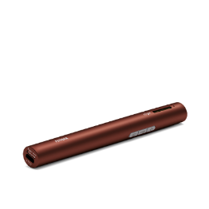

Phonak Roger Pen Transmitter

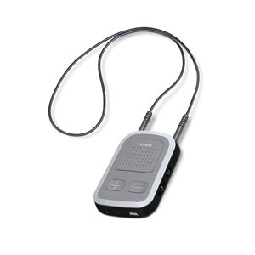

Phonak ComPilot

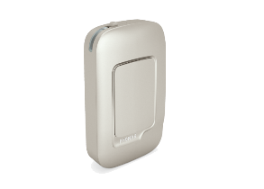

Phonak ComPilot Air II

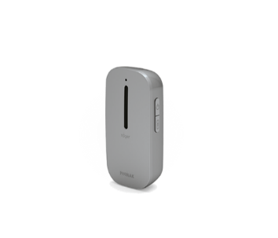

Phonak Clip-on Mic

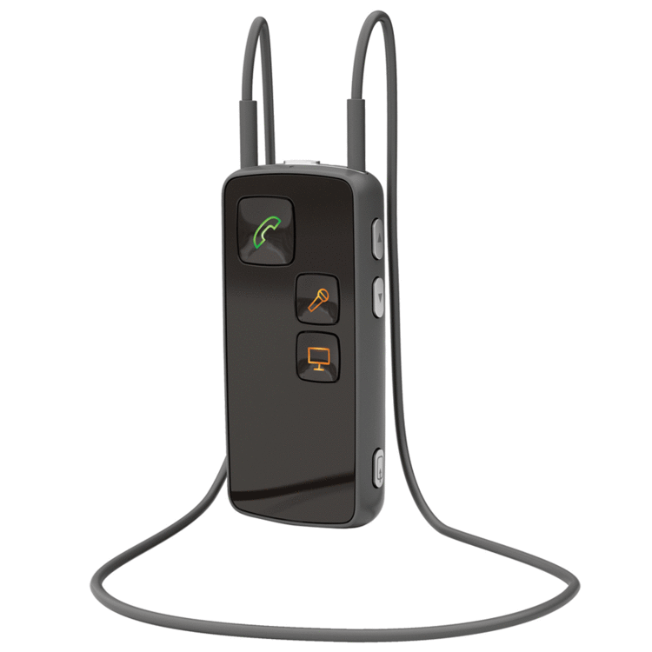

Oticon Streamer Pro

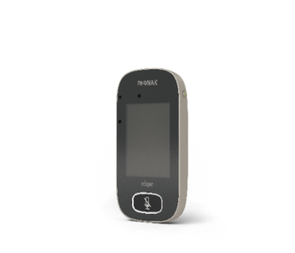

Phonak Touchscreen Transmitter

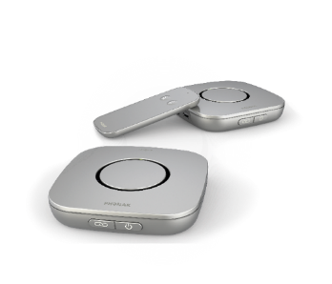

Phonak Table Mic

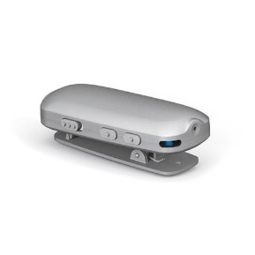

Phonak Remote Mic

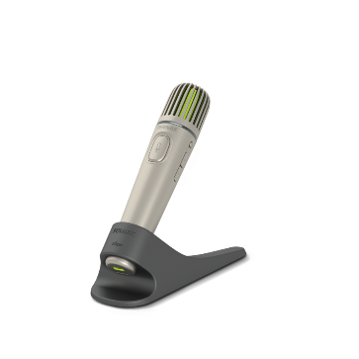

Phonak Pass Around Mic